EXPLORATORY DATA ANALYSIS
ON TITANIC DATASET

Tools Used:
- Python
- Pandas
- Matplotlib
- Seaborn

Dataset Description:
The dataset contains passenger information from the RMS Titanic sinking including age, gender, ticket class, fare, and survival status.

Data Analysis:

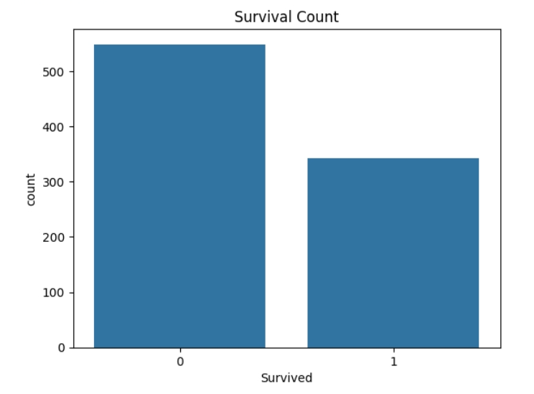
- Survival Graph:

- Age Distribution Graph:
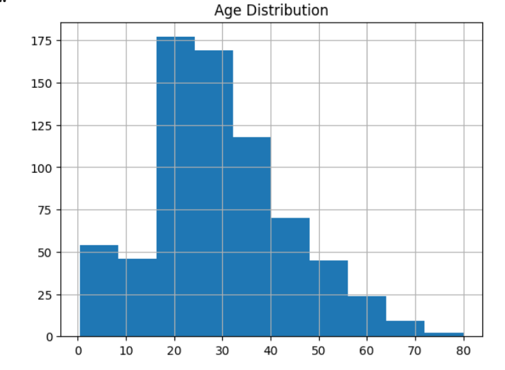

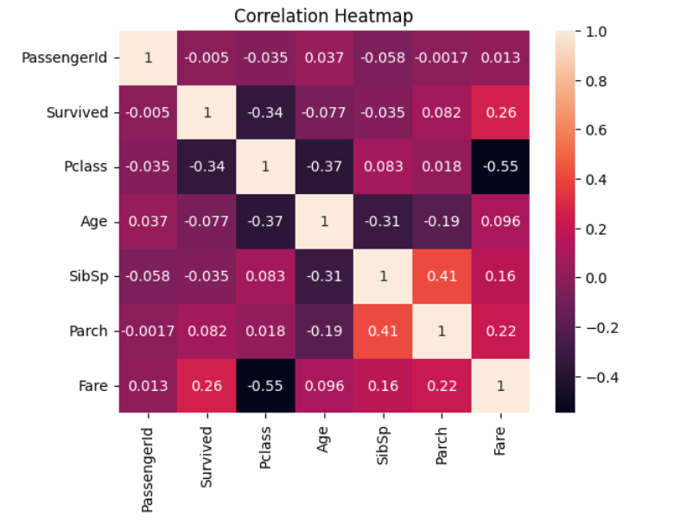
- Correlation Heatmap:

- Boxplot:
